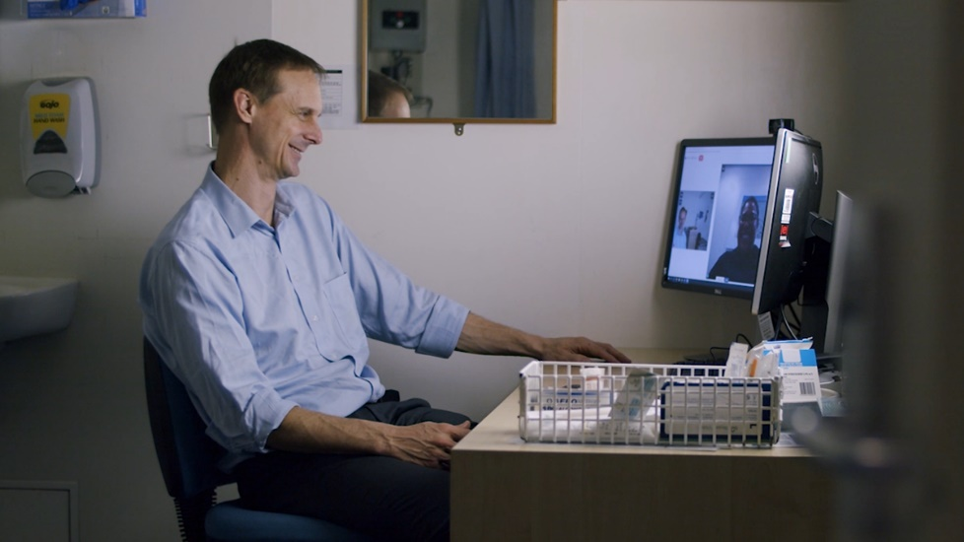
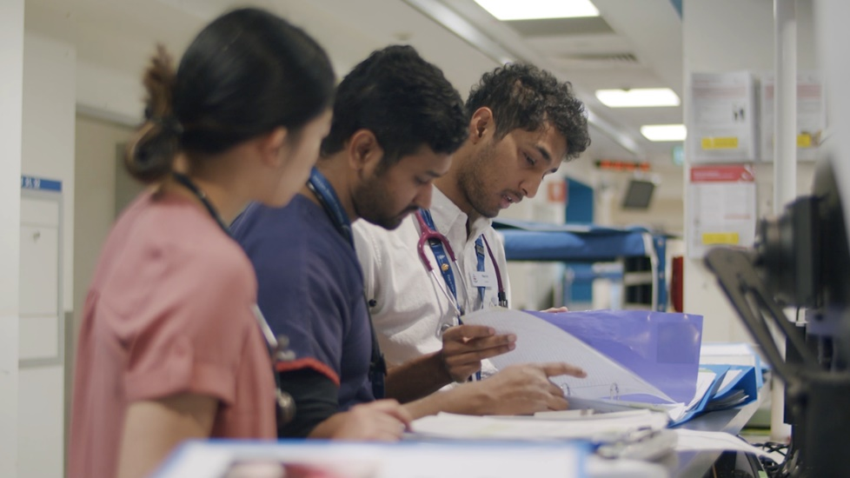
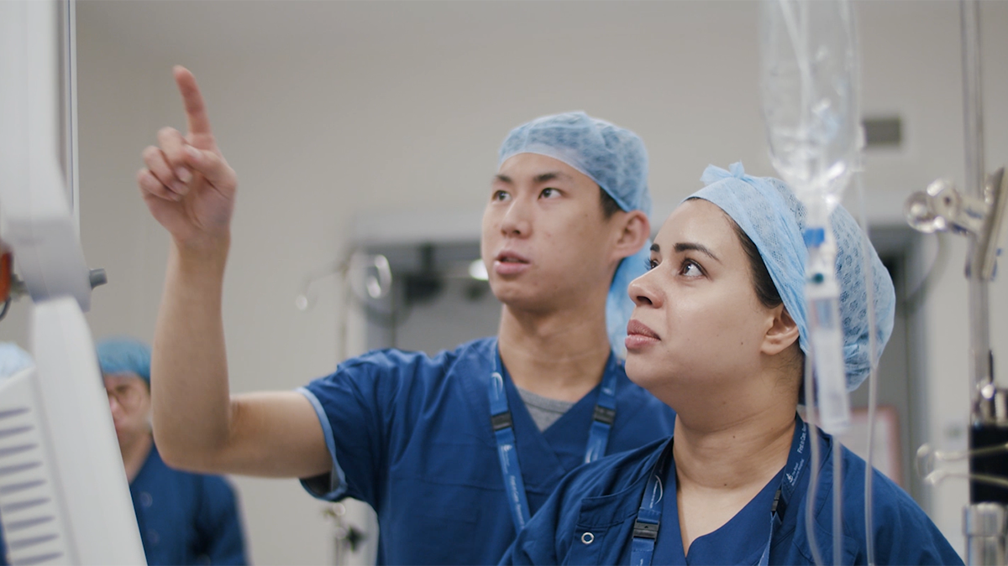
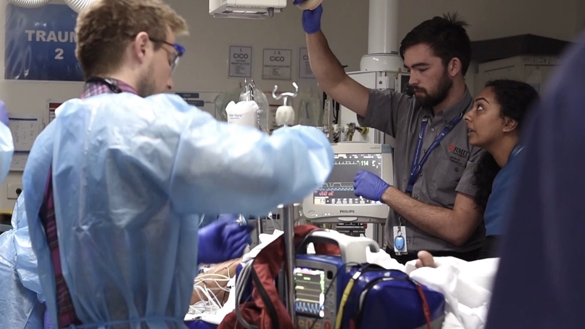

Advancing health for everyone, everyday.
  - Could this be you?
Join The Royal
Melbourne
Hospital Team

THE ROYAL MELBOURNE HOSPITAL
The Royal Melbourne Hospital (RMH) began in 1848 as Victoria’s first public hospital. And while we only had 10 beds to our name, we had the community of Melbourne behind us, and we were ready to provide the best possible care for those in need.
Since those early years, we’ve moved forward with purpose. Always at the forefront, leading the way on improving the quality of life for all.
Today the RMH is one of the largest health providers in the state, providing a comprehensive range of specialist medical, surgical, and mental health services; as well as rehabilitation, aged care, outpatient and community programs.
Our reputation for caring for all Melburnians is as essential to who we are as any scientific breakthrough we make. We’re here when it matters most, and we’ll continue to be the first to speak out for our diverse community’s wellbeing.
Our Vision
Advancing health for everyone, every day.
The Melbourne Way
At The RMH we’re inspired by our vision of Advancing health for everyone, every day. While we’re each going about our different roles, we’re united by a shared understanding of the way we do things around here. We call it The Melbourne Way. We put people first — leading with kindness and working together, we excel as one Royal Melbourne Hospital.
  People
  First
  Lead with Kindness
  Excellence Together
People are at the heart of everything we do. We take the time to understand how we can make the most positive difference for them. |  | Our care and compassion sets us apart. We lead the way with a respectful, inclusive spirit — embracing the things that make us all unique. |  | True excellence is only possible when we work as one Royal Melbourne Hospital community. Through collaboration, we set the highest of standards and achieve our goals.

Our Priorities
The RMH Strategic Plan: Towards 2025. Advancing health for everyone, every day is our plan for the future — one which we are committed to achieving together. This position contributes to the achievement of the five Strategic Goals, articulated in the plan:
- Be a great place to work and a great place to receive care
- Grow our Home First approach
- Realise the potential of the Melbourne Biomedical Precinct
- Become a digital health service
- Strive for sustainability

Position Description
Position Title: | Neurology - MS & CAR-T Clinical Fellow
Service: | Medical Services
Location: | The RMH Parkville
Reports To: | Head of Neuroimmunology
Enterprise Agreement: | AMA Victoria - Victorian Public Health Sector – Doctors in Training Enterprise Agreement 2022–2026
Classification: | HM25+, as per EBA
Employment Status: | Part Time / Fixed Term
Immunisation Risk Category: | Category A
Date of Review: | May 2026

Position SUMMARY
The Royal Melbourne Hospital Neuroimmunology Centre is offering a 1-year MS and CAR-T Clinical Fellowship. The position is accredited by the Royal Australian College of Physicians as non-core training in neurology. The Fellow will be an Australian or overseas trained neurology trainee who has completed core years of neurology training.

The fellow will receive specialist training in Multiple Sclerosis and Neuro-oncology, with focus on diagnosis, treatment and management of neurological complications of oncological conditions and therapies, in particular CAR T-Cell therapy. Each week, the fellow will attend 1-2 MS/neuroimmunology outpatient clinics, 1 neurology clinic at Peter McCallum Cancer Centre (PMCC), they will participate in management of MS therapy in Day Infusion Centre (2-3 short safety infusion clinics) and General Neurology outpatient clinics (up to 1 clinic), and will receive training in MS and neuroimmunology – oriented clinical trials. This is a full-time clinical (50%) and research (50%) role and the fellow will develop and pursue research projects within our established research streams. Extension of the fellowship into a PhD program can be negotiated. The Fellow will report to the Head of Multiple Sclerosis and other senior Neurology consultants within the MS Service and Neuro-immunology, and the Head of CAR T Cell program and other senior Haematology consultants at Peter MacCallum Institute.

As a Neurology fellow your contracted hours will cover your core subspecialty and general neurology clinical activity. Outside these hours, for your professional development and to satisfy your training requirements, you will have the opportunity to participate in activities focusing on clinical education and research as recommended by your supervisor(s) and the director of Neurology. There is no after-hours commitment pertaining to this position.

DEPARTMENT DESCRIPTION
Department of Neurology – RMH Neuroimmunology Centre

Melbourne as a city is a hub of clinical excellence, research and innovation in the field of multiple sclerosis. It is an ideal setting for training future clinicians and leaders in the management of people with MS or related conditions. The Royal Melbourne Hospital Neuroimmunology Centre is the home of an academic and clinical program supported by 8 neurologists, 2 fellows, registrar, and 4 research nurse coordinators. The program includes laboratory, clinical, applied and outcome research streams.

The RMH MS program offers a full range of inpatient and outpatient services at the RMH City & Elizabeth Street Campus’, where transport and interpreter services are available.

Referral to relevant service providers such as physiotherapists, occupational therapists, neuropsychiatrists and geriatricians are included in the assessment and treatment services.

The Department is dedicated to clinically relevant research related to MS including research involving use of new therapies and technology, and the monitoring of responses of patients to treatment over prolonged periods.

Key Accountabilities
- play a key role in the coordination of patient care (including arranging investigations, medication changes, and oversight of the safety of immunomodulatory therapy) on behalf of Neuroimmunology.  - attendance at weekly Neurology clinic at VCCC  - triaging, reviewing and managing referrals of patients with neurological complications of treatment for oncological diseases to RMH Neurology  - participation in the provision of care in the Day Infusion Centre  - participation in General Neurology Ambulatory Service  - Where appropriate, attendance and participation in the weekly Neurology Grand Rounds and Clinical Neuroscience  - Attendance at the weekly Neurology audit meeting  - Participation in the assessment of patients enrolled in MS oriented clinical trials and observational studies  - Scoping and development of a clinically oriented investigator-driven research study under the supervision of the Neuroimmunology consultants constitutes 50% of this role. | - Take reasonable care for your safety and wellbeing and that of others.  - Work in your scope of practice and seek help where required.  - Work in partnership with consumers, patients and where applicable carers and families.  - Work collaboratively with colleagues across all RMH teams.  - Continue to learn through mandatory training and other learning activities.  - Seek feedback on your work including participation in annual performance discussion.  - Speak up for safety, our values and wellbeing.  - Prioritise wellbeing and ensure safe work practices are developed and adhered to in their area.  - Respect that the RMH is a smoke-free environment.

Key Relationships
Internal | External
- Neurology Department  - Inpatient and outpatient services  - RMH Staff | - Patients / Consumers  - Family Members

Key Selection Criteria

Formal Qualifications:
- Registration with the Medical Board of Australia (AHPRA) or eligible for registration with the Medical Board of Australia (for international Medical Graduates)
- MBBS or equivalent tertiary qualifications who have trained and completed core years of Neurology training (or local equivalent)

Essential:
- Commitment to live the Melbourne Way - putting people first, leading with kindness and achieving excellence together.
- Mandatory Working with Children's Check and Police Check and Immunisation Assessment
- Australian or overseas trained Neurology Trainee who has completed core years of Neurology training
- (or local equivalent)
- Well-developed interpersonal skills and demonstrated ability to participate in and enhance the activities of clinical teams in multidisciplinary, collaborative care.
- Track record in pursuit of clinical excellence.

Desirable:
- Track record of relevant peer-reviewed published research work.
- Post graduate research qualification – MD, PhD or equivalent.
- Experience in clinical research.

Key Performance Indicators
Your performance will be measured through your successful:
- Demonstration of RMH values
- Achievement of portfolio specific KPI targets
- Participation in and satisfactory feedback through the annual performance review process
- Ability to maintain a safe working environment and ensure compliance with legislative requirements

At the RMH we:
- Aim to provide a working environment that is safe and without risk to the health, safety and wellbeing of all employees, patients and consumers, and visitors.
- Speak up for patient, consumer, colleague and visitor safety, escalating issues if required.
- Deliver Safe, Timely, Equitable, Person-centred Care (STEP) in line with our clinical governance framework.
- Work in accordance with relevant policies, procedures, standards and legislation including those related to clinical or competency requirements, risk management, discrimination, equal opportunity and health safety and wellbeing.

OUR COMMITMENT:
- Equity, Inclusion, Belonging and Safety
  - As a leader in healthcare, we recognise the need to foster a culture of equity, inclusion, and belonging — safe spaces where every individual is empowered to be their authentic self, contributing meaningfully to the collective well-being of our community.
- First Nations Commitment
  - We acknowledge and pay our respects to the Traditional Owners of the lands on which we work and stand in solidarity with Aboriginal and Torres Strait Islander peoples. We are committed to creating a culturally safe environment that honours First Nations voices, knowledge, and self-determination through inclusive governance, respectful policies, and a steadfast commitment to anti-racism. The Royal Melbourne aspires to lead by example in addressing the injustices of colonisation and its ongoing impacts.
- Child Safe Standards
  - RMH is a child safe organisation. We are dedicated to fostering an environment that respects and upholds the rights of children and young people, in line with the Child Safe Standards. We actively embed these standards in our culture, policies, and practices, ensuring that the safety and wellbeing of children and young people is a central priority.
- Equal Opportunity and Accessibility
  - We are proud to be an equal opportunity employer that champions diversity in all its forms. We value the strengths and perspectives that come from people of all backgrounds, identities, abilities, and lived experiences. We encourage applicants from all communities, and we will provide reasonable adjustments to support equitable participation.
- Thriving Together
  - Together, we are committed to fostering an environment where everyone feels respected, safe, and empowered to thrive.

Acceptance
I acknowledge and accept that this position description represents the duties, responsibilities and accountabilities that are expected of me in my employment in the position. I understand that The RMH reserves the right to modify position descriptions as required, however I will be consulted when this occurs.
Employee Signature
Employee Name (please print)
Date

