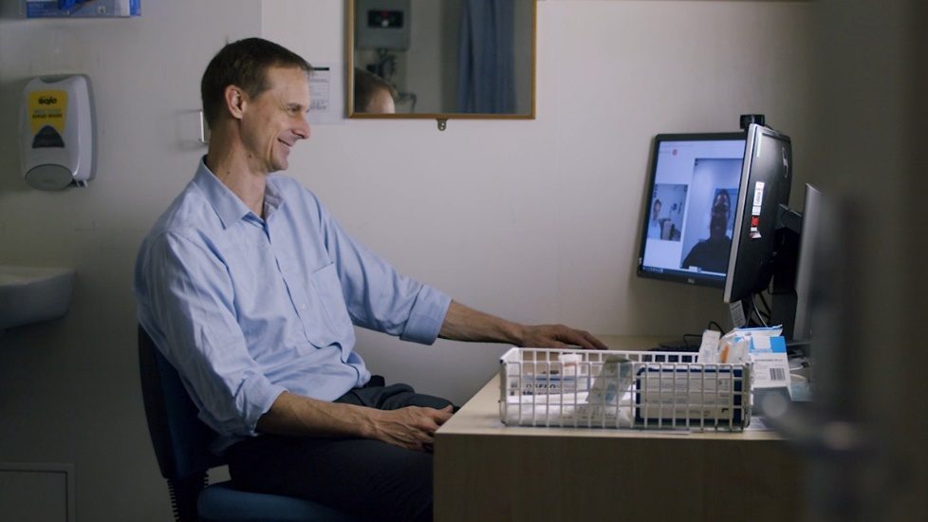
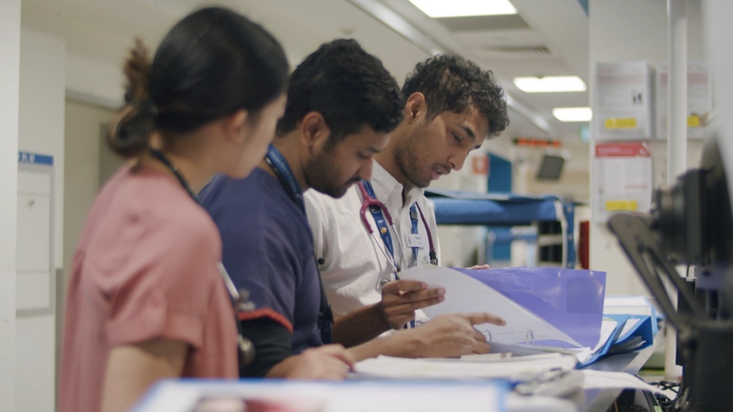
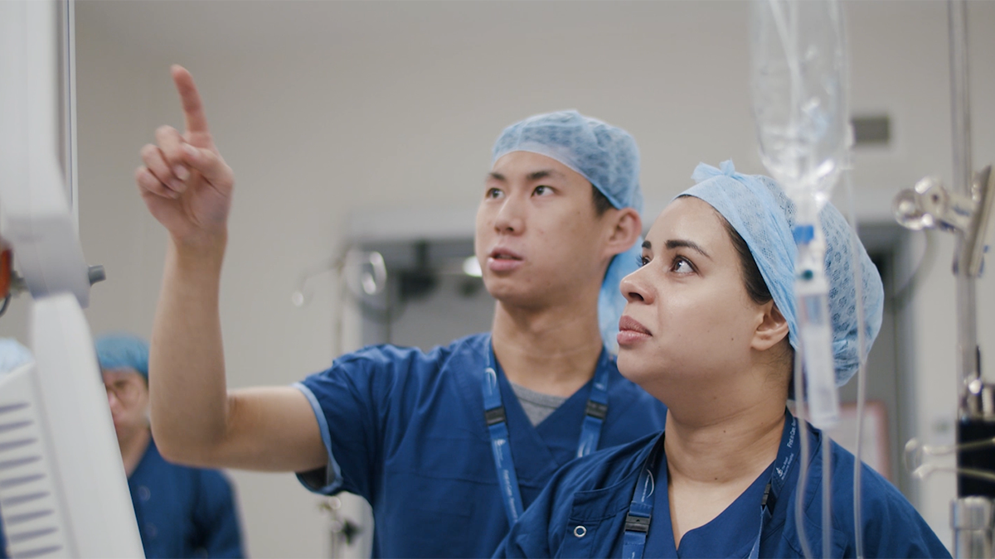
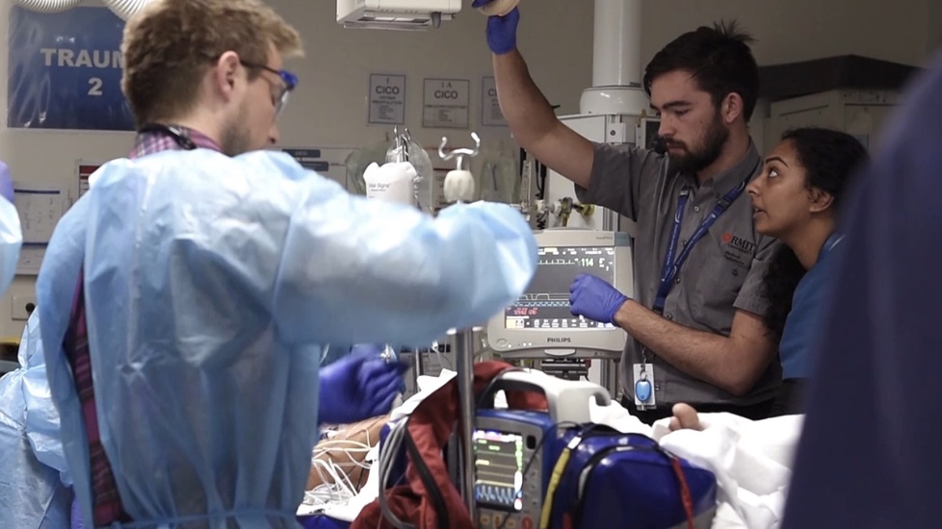

Advancing health for everyone, everyday.
  - Could this be you?
Join The Royal
Melbourne
Hospital Team

THE ROYAL MELBOURNE HOSPITAL
The Royal Melbourne Hospital (RMH) began in 1848 as Victoria’s first public hospital. And while we only had 10 beds to our name, we had the community of Melbourne behind us, and we were ready to provide the best possible care for those in need.
Since those early years, we’ve moved forward with purpose. Always at the forefront, leading the way on improving the quality of life for all.
Today the RMH is one of the largest health providers in the state, providing a comprehensive range of specialist medical, surgical, and mental health services; as well as rehabilitation, aged care, outpatient and community programs.
Our reputation for caring for all Melburnians is as essential to who we are as any scientific breakthrough we make. We’re here when it matters most, and we’ll continue to be the first to speak out for our diverse community’s wellbeing.
Our Vision
Advancing health for everyone, every day.
The Melbourne Way
At The RMH we’re inspired by our vision of Advancing health for everyone, every day. While we’re each going about our different roles, we’re united by a shared understanding of the way we do things around here. We call it The Melbourne Way. We put people first — leading with kindness and working together, we excel as one Royal Melbourne Hospital.
  People
  First
  Lead with Kindness
  Excellence Together
People are at the heart of everything we do. We take the time to understand how we can make the most positive difference for them. |  | Our care and compassion sets us apart. We lead the way with a respectful, inclusive spirit — embracing the things that make us all unique. |  | True excellence is only possible when we work as one Royal Melbourne Hospital community. Through collaboration, we set the highest of standards and achieve our goals.

Our Priorities
The RMH Strategic Plan: Towards 2025. Advancing health for everyone, every day is our plan for the future — one which we are committed to achieving together. This position contributes to the achievement of the five Strategic Goals, articulated in the plan:
- Be a great place to work and a great place to receive care
- Grow our Home First approach
- Realise the potential of the Melbourne Biomedical Precinct
- Become a digital health service
- Strive for sustainability

Position Description
Position Title: | Plastics and Reconstructive Surgery Registrar - Unaccredited
Service: | Plastics and Reconstructive Surgery
Location: | The RMH Parkville
Reports To: | Head of Unit – Plastics and Reconstructive Surgery
Enterprise Agreement: | AMA Victoria - Victorian Public Health Sector – Doctors in Training Enterprise Agreement 2022–2026
Classification: | HM25+ - as per EBA
Employment Status: | Fixed Term / Full Time
Immunisation Risk Category: | Category A
Date of Review: | April 2026

Position SUMMARY
The role of the Registrar is to provide clinical leadership and management of patients and undertake clinical duties for the Plastic and Reconstructive Surgery Unit under the supervision and direction of the Department Head of Unit and Consultant staff. The Plastic and Reconstructive Surgery Unaccredited Registrar position is based at the Royal Melbourne Hospital, Parkville Campus. Applications are encouraged from suitably qualified doctors with prior Resident and Registrar experience and interest in Plastic Surgery.

The successful applicants will be expected to work closely with the Unit consultants, Accredited Registrars and Fellows at the Royal Melbourne Hospital department of Plastic Surgery sharing the running duties of this busy department. The successful candidates will be exposed to a broad range of plastic and reconstructive surgery, including non-elective surgery.

Department description
The RMH Plastic & Reconstructive Surgery Unit has 16 attending Plastic Surgeons, 3 local Accredited Registrars, 2 International fellows, 3 local Unaccredited Registrar and 6 Residents. The Unit specialises in microsurgical reconstruction for breast, head & neck cancer and lower limb trauma. The Unit also manages a large number of general plastic surgery cases, including elective and post-traumatic hand surgery, facial trauma, brachial plexus injuries, melanoma and provides a broad reconstructive service to all specialties.

The Royal Melbourne Hospital is one of Victoria’s leading tertiary referral hospitals. It is a major trauma centre and provides all specialist medical and surgical services. The Hospital is a privileged member of Melbourne's world-leading Parkville Precinct and enjoys strong relationships with many of the city's major universities and research institutes.

Key Accountabilities
- Take reasonable care for your safety and wellbeing and that of others.  - Work in your scope of practice and seek help where required.  - Work in partnership with consumers, patients and where applicable carers and families.  - Work collaboratively with colleagues across all RMH teams.  - Continue to learn through mandatory training and other learning activities.  - Seek feedback on your work including participation in annual performance discussion.  - Speak up for safety, our values and wellbeing.  - Prioritise wellbeing and ensure safe work practices are developed and adhered to in their area.  - Respect that the RMH is a smoke-free environment.  - Participate in Plastics & Reconstructive Surgery Unit and the Royal Melbourne Hospital clinical and administrative audit and quality improvement activities.  - Participate in the Australian Council of Healthcare Service Standards Accreditation and EQuIP programs. | - Ensure direct reports receive regular feedback and participate in annual discussions.  - Contribute to organisation-wide and service/division initiatives and planning activities.  - Ensure training needs of direct reports are identified and undertaken.  - Ensure risk management activities are completed, effective controls are in place and incidents are recorded, investigated and corrective actions implemented as far as is reasonably practical.  - Create a psychologically safe work environment where everyone feels safe to speak up. Monitor and achieve relevant KPIs and targets and operate within their allocated budget.  - Ensure appropriate plans are developed for the Division, ongoing staff training and development.  - Support and facilitate education and research within Plastics & Reconstructive Surgery Unit.  - Facilitate consultations across the remainder of the hospital for Plastics & Reconstructive Surgery Unit in a timely and efficient manner.

Key Relationships
Internal | External
- Consultants  - Registrars / residents  - Nursing & Administrative Staff  - Allied Health Staff  - Ward Clerks & Clinical Assistants  - Administrative Staff | - Patients  - General Practitioners  - Other Specialist Consultants

Key Selection Criteria
Formal Qualifications:
- Current General Registration with The Medical Board of Australia (AHPRA) or eligible for registration with the Medical Board of Australia (for international Medical Graduates)
- Appropriate Health Professional Tertiary qualifications – MBBS or equivalent

Essential:
- Commitment to live the Melbourne Way - putting people first, leading with kindness and achieving excellence together.
- Strong leadership skills
- Strong organisational skills
- Ability to work in a team
- Strategic thinking and planning abilities
- Well-developed communication and presentation skills

Key Performance Indicators
Your performance will be measured through your successful:
- Demonstration of RMH values
- Achievement of portfolio specific KPI targets
- Participation in and satisfactory feedback through the annual performance review process
- Ability to maintain a safe working environment and ensure compliance with legislative requirements

At the RMH we:
- Aim to provide a working environment that is safe and without risk to the health, safety and wellbeing of all employees, patients and consumers, and visitors.
- Speak up for patient, consumer, colleague and visitor safety, escalating issues if required.
- Deliver Safe, Timely, Equitable, Person-centred Care (STEP) in line with our clinical governance framework.
- Work in accordance with relevant policies, procedures, standards and legislation including those related to clinical or competency requirements, risk management, discrimination, equal opportunity and health safety and wellbeing.

OUR COMMITMENT:
- Equity, Inclusion, Belonging and Safety
  - As a leader in healthcare, we recognise the need to foster a culture of equity, inclusion, and belonging — safe spaces where every individual is empowered to be their authentic self, contributing meaningfully to the collective well-being of our community.
- First Nations Commitment
  - We acknowledge and pay our respects to the Traditional Owners of the lands on which we work and stand in solidarity with Aboriginal and Torres Strait Islander peoples. We are committed to creating a culturally safe environment that honours First Nations voices, knowledge, and self-determination through inclusive governance, respectful policies, and a steadfast commitment to anti-racism. The Royal Melbourne aspires to lead by example in addressing the injustices of colonisation and its ongoing impacts.
- Child Safe Standards
  - RMH is a child safe organisation. We are dedicated to fostering an environment that respects and upholds the rights of children and young people, in line with the Child Safe Standards. We actively embed these standards in our culture, policies, and practices, ensuring that the safety and wellbeing of children and young people is a central priority.
- Equal Opportunity and Accessibility
  - We are proud to be an equal opportunity employer that champions diversity in all its forms. We value the strengths and perspectives that come from people of all backgrounds, identities, abilities, and lived experiences. We encourage applicants from all communities, and we will provide reasonable adjustments to support equitable participation.
- Thriving Together
  - Together, we are committed to fostering an environment where everyone feels respected, safe, and empowered to thrive.

Acceptance
I acknowledge and accept that this position description represents the duties, responsibilities and accountabilities that are expected of me in my employment in the position. I understand that The RMH reserves the right to modify position descriptions as required, however I will be consulted when this occurs.
Employee Signature
Employee Name (please print)
Date

