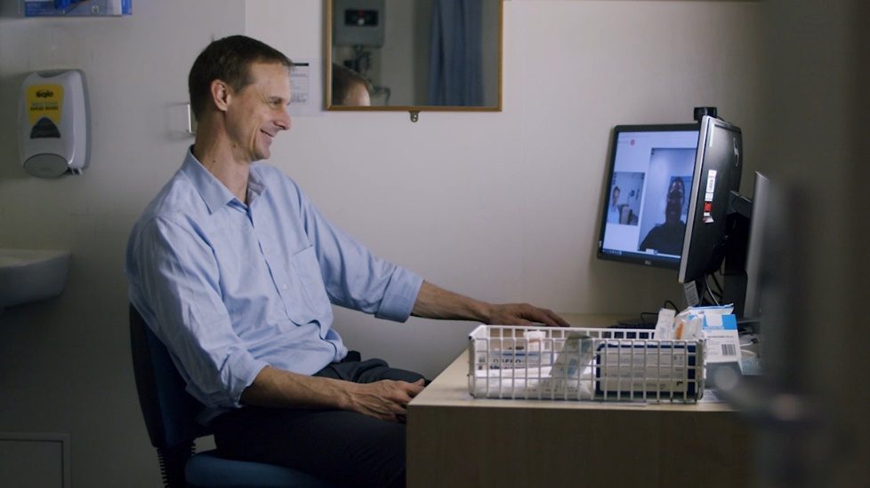
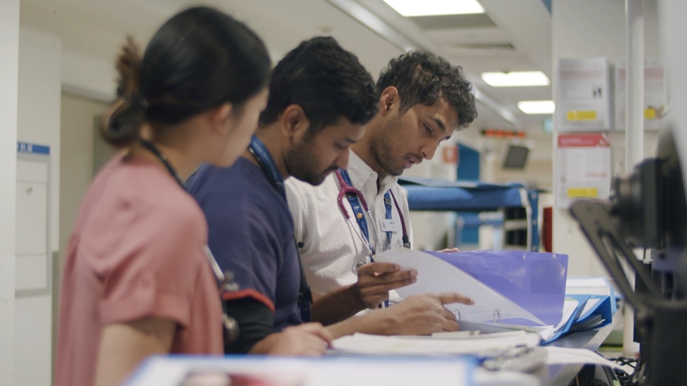
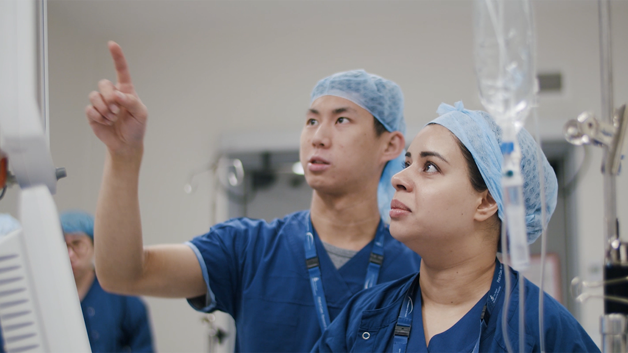
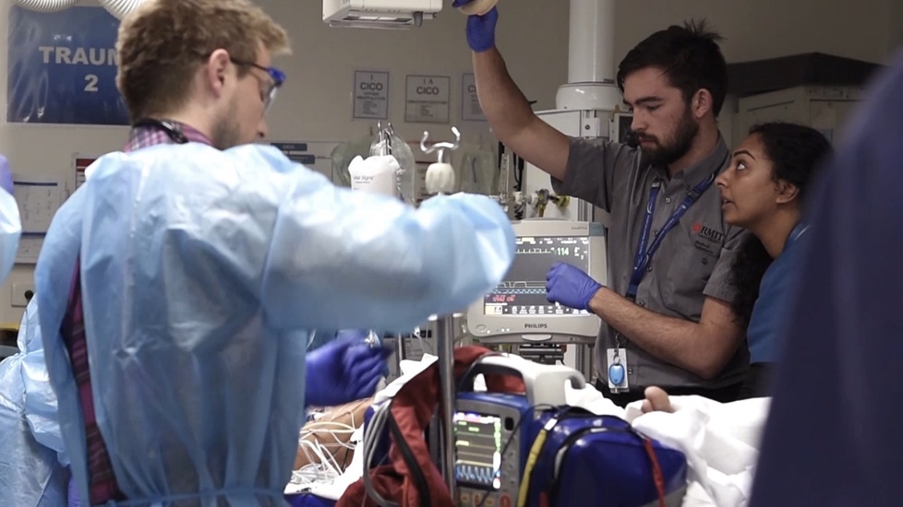

Advancing health for everyone, everyday.
  - Could this be you?
Join The Royal
Melbourne
Hospital Team

THE ROYAL MELBOURNE HOSPITAL
The Royal Melbourne Hospital (RMH) began in 1848 as Victoria’s first public hospital. And while we only had 10 beds to our name, we had the community of Melbourne behind us, and we were ready to provide the best possible care for those in need.
Since those early years, we’ve moved forward with purpose. Always at the forefront, leading the way on improving the quality of life for all.
Today the RMH is one of the largest health providers in the state, providing a comprehensive range of specialist medical, surgical, and mental health services; as well as rehabilitation, aged care, outpatient and community programs.
Our reputation for caring for all Melburnians is as essential to who we are as any scientific breakthrough we make. We’re here when it matters most, and we’ll continue to be the first to speak out for our diverse community’s wellbeing.
Our Vision
Advancing health for everyone, every day.
The Melbourne Way
At The RMH we’re inspired by our vision of Advancing health for everyone, every day. While we’re each going about our different roles, we’re united by a shared understanding of the way we do things around here. We call it The Melbourne Way. We put people first — leading with kindness and working together, we excel as one Royal Melbourne Hospital.
  People
  First
  Lead with Kindness
  Excellence Together
People are at the heart of everything we do. We take the time to understand how we can make the most positive difference for them. |  | Our care and compassion sets us apart. We lead the way with a respectful, inclusive spirit — embracing the things that make us all unique. |  | True excellence is only possible when we work as one Royal Melbourne Hospital community. Through collaboration, we set the highest of standards and achieve our goals.

Our Priorities
The RMH Strategic Plan: Towards 2025. Advancing health for everyone, every day is our plan for the future — one which we are committed to achieving together. This position contributes to the achievement of the five Strategic Goals, articulated in the plan:
- Be a great place to work and a great place to receive care
- Grow our Home First approach
- Realise the potential of the Melbourne Biomedical Precinct
- Become a digital health service
- Strive for sustainability

Position Description
Position Title: | Security Services Manager
Service: | Nursing Services
Location: | Multiple Locations of The Royal Melbourne Hospital
Reports To: | Director Security & Safety
Enterprise Agreement: | Victorian Public Health Sector (Health and Allied Services, Managers and Administrative Workers) Single Interest Enterprise Agreement 2021–2025
Classification: | HS5
Employment Status: | Full Time
Immunisation Risk Category: | Category C
Date of Review: | January 2026

Position Summary

The Security Services Manager leads the operational Security response and managing Control Room functions across RMH, while promoting a safe and supportive environment for everyone.

The role oversees 24/7 security operations, systems, and procedures, promoting excellence in service delivery, compliance, and stakeholder collaboration.
.
In conjunction with the Director Security & Safety, the role will enhance, systems, processes and procedures including Control Room operations, monitoring and reporting industry trends within security services.

The role makes a strong contribution to ensuring all applicable procedures, polices, compliance requirements and KPIs are achieved while fostering a high standard of service delivery through collaboration with hospital staff and stakeholder cross multiple sites.

We welcome individuals who are committed to contributing to a safe healthcare environment and upholding our vision of advancing health for everyone, every day. If you are dedicated to creating a safe and welcoming space for all, we encourage you to apply and become a valued member of our Security Services team.

Key Accountabilities
- Take reasonable care for your safety and wellbeing and that of others.  - Work in your scope of practice and seek help where required.  - Work in partnership with consumers, patients and where applicable carers and families.  - Work collaboratively with colleagues across all RMH teams.  - Continue to learn through mandatory training and other learning activities.  - Seek feedback on your work including participation in annual performance discussion.  - Speak up for safety, our values and wellbeing.  - Prioritise wellbeing and ensure safe work practices are developed and adhered to in their area.  - Respect that the RMH is a smoke-free environment.  - Lead the Security team in all facets including financial, human resources, technology and equipment, quality and risk, and customer service management.  - Establish and maintain effective communication and customer service systems are in place to ensure the security team are highly regarded.  - Develop security service contracts, engage service providers and industry specialists and assist in developing initiatives and projects aligned with industry best practice standards & legislation.  - Develop annual budget forecasts and strategies to ensure business operation needs are met in accordance with budget allocation.  - Conduct periodic reviews of security and safety services, report results and recommend opportunities for continuous improvement accountability.  - Coordinate recruitment of appropriately credentialed security officers to support effective workforce planning and leave management and to reduce reliance on contract staff. | - Ensure direct reports receive regular feedback and participate in annual discussions.  - Contribute to organisation-wide and service/division initiatives and planning activities.  - Ensure training needs of direct reports are identified and undertaken including delivering training and supporting team members to a new level of capability and well-being.  - Ensure an appropriate operational model and supporting operations manual is in place and all members of the team are competent in its requirements and associated procedures.  - Delivers timely responses to requests for security services  - Ensure appropriate systems are in place to assess and manage risk, including the identification and management of vulnerable areas, critical assets and high risk locations / situations across the various sites of the health service.  - Ensure risk management activities are completed, effective controls are in place and incidents are recorded, investigated and corrective actions implemented as far as is reasonably practical.  - Develop, implement and review security & emergency management policies and procedures.  - Contribute to the organisations emergency management, business continuity and critical incident plans.  - Work with other areas of the organisation and precinct to achieve shared outcomes in security, safety, well-being and patient/consumer care.  - Create a psychologically safe work environment where everyone feels safe to speak up.  - Achieve goals, plans and KPIs according to strategic and annual operational plan and report accordingly.

Key Relationships
Internal | External
- Director Security & Safety  - Security Operations Coordinator/ Team Leaders  - Security Officers (Response & Control Room)  - Occupational Violence & Aggression Nurse Consultancy Service  - Emergency Management  - Digital Coordination Centre  - Facilities Management  - Switchboard  - Legal and Medicolegal Services  - Executive & Senior Leadership Team | - Victoria Police  - Public Safety Offices (Metro Trains)  - Ambulance Victoria  - Fire Rescue Victoria  - Precinct partners  - Patients/ Consumers  - Visitors & Carers  - Government stakeholders  - Local pubic transport providers

Key Selection Criteria
    - Formal Qualifications:
- Degree level qualification in relevant field (essential)
- Further qualifications in leadership, change management or other related discipline ( highly desirable)
    - Essential:
- Commitment to live the Melbourne Way - putting people first, leading with kindness and achieving excellence together.
- Working with Children’s Check and Police Check
- Proven senior experience in security management within complex organisations
- Expertise in OH&S and security risk assessment and control
- Experience delivering security-related projects
- Strong leadership, communication, and interpersonal skills
- Knowledge of security, legal, and regulatory frameworks
- Financial and operational management experience
- Proficiency with Microsoft Office and security systems (e.g.Milestone, Integriti)
- Current Security & Crowd Control Licence, Certificate II/III (with Control Room endorsement), Working with Children Check, and Driver’s Licence
    - Desirable:
- Qualifications or extensive experience and management expertise in Emergency, Critical Incident, Business Continuity or Risk management.
- Healthcare experience.

Key Performance Indicators
Your performance will be measured through your successful:
- Alignment with RMH values and strategic goals
- Achievement of operational KPIs and compliance standards
- Effective leadership and staff engagement
- Maintenance of a safe, high-quality security service
- Positive performance review outcomes

At the RMH we:
- Aim to provide a working environment that is safe and without risk to the health, safety and wellbeing of all employees, patients and consumers, and visitors.
- Speak up for patient, consumer, colleague and visitor safety, escalating issues if required.
- Deliver Safe, Timely, Equitable, Person-centred Care (STEP) in line with our clinical governance framework.
- Work in accordance with relevant policies, procedures, standards and legislation including those related to clinical or competency requirements, risk management, discrimination, equal opportunity and health safety and wellbeing.

OUR COMMITMENT:
- Equity, Inclusion, Belonging and Safety
  - As a leader in healthcare, we recognise the need to foster a culture of equity, inclusion, and belonging — safe spaces where every individual is empowered to be their authentic self, contributing meaningfully to the collective well-being of our community.
- First Nations Commitment
  - We acknowledge and pay our respects to the Traditional Owners of the lands on which we work and stand in solidarity with Aboriginal and Torres Strait Islander peoples. We are committed to creating a culturally safe environment that honours First Nations voices, knowledge, and self-determination through inclusive governance, respectful policies, and a steadfast commitment to anti-racism. The Royal Melbourne aspires to lead by example in addressing the injustices of colonisation and its ongoing impacts.
- Child Safe Standards
  - RMH is a child safe organisation. We are dedicated to fostering an environment that respects and upholds the rights of children and young people, in line with the Child Safe Standards. We actively embed these standards in our culture, policies, and practices, ensuring that the safety and wellbeing of children and young people is a central priority.
- Equal Opportunity and Accessibility
  - We are proud to be an equal opportunity employer that champions diversity in all its forms. We value the strengths and perspectives that come from people of all backgrounds, identities, abilities, and lived experiences. We encourage applicants from all communities, and we will provide reasonable adjustments to support equitable participation.
- Thriving Together
  - Together, we are committed to fostering an environment where everyone feels respected, safe, and empowered to thrive.

Acceptance
I acknowledge and accept that this position description represents the duties, responsibilities and accountabilities that are expected of me in my employment in the position. I understand that The RMH reserves the right to modify position descriptions as required, however I will be consulted when this occurs.
Employee Signature
Employee Name (please print)
Date

